EF Code First Migration Guidelines

* Generate the delta snapshot for the changes

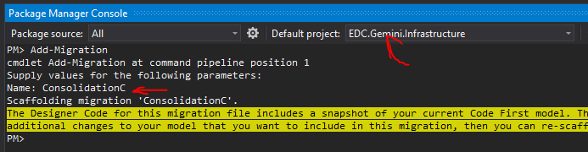

Then EF Framework generates a migration class called “201910311920157_ConsolidationC.cs” based on the calculation of last generated snapshot.

The migration class contains Up() and Down() method

* Up() method is to introduce changes into the database
* Down() method is to roll back changes to the current version before applying Up()

EF framework will execute all the migration code first then execute the Seed() method defined in Configration.cs

* Merge: Don’t delete the previous migration cs file, should add the latest generated code into the previous migration cs file since there might be some manual changes in the previous migration cs file. E.g. Default Value which won’t auto generated (the red highlighted part below).

|  |
| --- |
| AddColumn("dbo.report", "newProperty",  c => c.String(nullable: false**, defaultValueSql: "GETDATE()")**); |

* Re-generate the database

First delete the existing old database

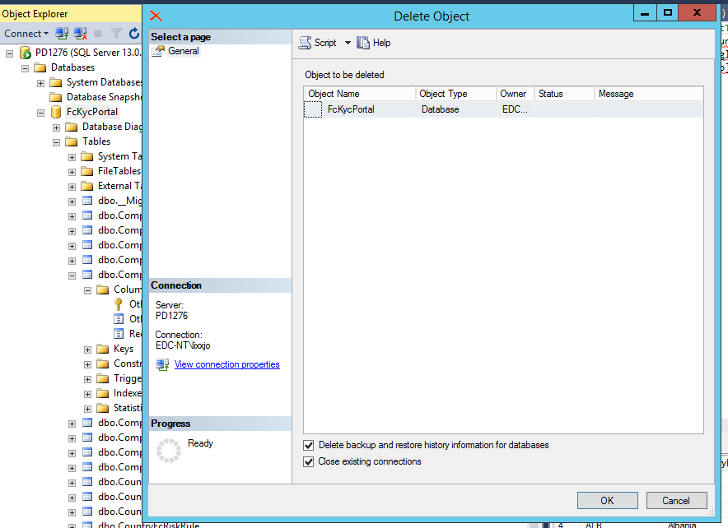

then Run “Update-Database” command in PM> console, make sure that the Default project is pointing to the EF Code First Project

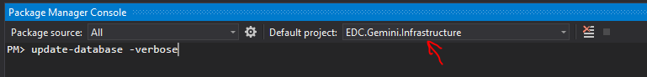

The Up method upgrades your database from its current state (represented by your previous migration) to the state expected by your current code migration. The Down method does the reverse operation - it removes all the changes from the current migration and reverts database to the state expected by the previous migration. It's like installing / uninstalling the migration. Only one of these methods is executed when you call update-database. To use the Down method you must explicitly specify the target migration for your upgrade. If the target migration is the old one, the migration API will automatically use the Down method and downgrade your database

For Example:

* 202010151456318_TransactionIntemediaryUpdate is the new migration
* 202009111938530_TransactionGeminiRisksInitial is the previous migration

To migrate to the new version, run:

* update-database -target 202010151456318_TransactionIntemediaryUpdate
* Run the Up() method in 202010151456318_TransactionIntemediaryUpdate.cs
* Run the Seed() method in Configuration.cs

To migrate back to the previous old version:

* update-database -target 202009111938530_TransactionGeminiRisksInitial
* Run the Down() method in 202010151456318_TransactionIntemediaryUpdate.cs
* But somehow seems not running the Seed() method in Configuration.cs